**Q1. Assume that your company is planning to construct a chemical factory in Navi**

**Mumbai. Who are the key stakeholders?**

**Why stakeholder analysis is important as a precondition of the decision whether or not**

**to follow through with such a plan? As a Project manager how are going to negotiate**

**With different stakeholders in the Project?**

**Ans.**

A “stakeholder” can be defined as: Any individual, group, or institution who has a vested

interest in the natural resources of the project area and/or who potentially will be affected by

project activities and have something to gain or lose if conditions change or stay the same.

Stakeholders are all those who need to be considered in achieving project goals and whose

participation and support are crucial to its success. Stakeholder analysis identifies all primary

and secondary stakeholders who have a vested interest in the issues with which the project or

policy is concerned. The goal of stakeholder analysis is to develop a strategic view of the

human and institutional landscape, and the relationships between the different stakeholders and

the issues they care about most.

Key Stakeholders are:

1. Employees: Employees want to work in a place where they can meet their personal needs and wants. Leaders who create job assignments, work environments, and visions help employees be both competent and committed to their work.
2. Customers: Customers want leaders to build compelling products and services so that they can trust and when they do, customers will give share of wallet.
3. Communities: Communities want leaders to build organizations that are socially responsible, through how they treat the environment and how they serve the larger community.
4. Investors: Investors want leaders to keep their promises, develop a compelling growth strategy, align core competencies to the strategy and then to ensure that people are committed to delivering on these premises. When they do, investors reward the organization with high levels of confidence in the future which translates into higher market value.
5. Regulators: Regulators want leaders to govern themselves in accordance with high ethical principles and in a manner consistent with professional and legal standards.

Principles of stakeholders analysis are:

A stakeholder analysis can help a project or programme identify:

* The interests of all stakeholders who may affect or be affected by the programme/project;
* Potential conflicts or risks that could jeopardise the initiative;
* Opportunities and relationships that can be built on during implementation;
* Groups that should be encouraged to participate in different stages of the project;
* Appropriate strategies and approaches for stakeholder engagement; and
* Ways to reduce negative impacts on vulnerable and disadvantaged groups.

The full participation of stakeholders in both project design and implementation of is a key to – but not a guarantee of – success. Stakeholder participation:

* Gives people some say over how projects or policies may affect their lives;
* Is essential for sustainability;
* Generates a sense of ownership if initiated early in the development process;
* Provides opportunities for learning for both the project team and stakeholders themselves; and
* Builds capacity and enhances responsibility.

Negotiation is necessary part in almost every area of the project, from defining scope to time required to accomplish the tasks, from resource allocation to cost and budget. This can involve one-on-one negotiation or with a group of people. It is important for a project manager to learn this art and to set realistic expectations regarding project risk and time required in both best and worst case scenarios. It is his responsibility to ensure that clients, sponsors, and other stakeholders understand the realities of project estimating.

Listing down the following:

1. Possible trade-offs among cost, scope, time, and quality with impact of change in one constraint over other.
2. Possible risks and extra budget required for risk response strategy.
3. If you are a technical project manager, try to take a better insight of the project by having a meeting with the relevant stakeholder or any subject matter expert.
4. One must be updated with the latest design and technology required for you project. Also does it support the requirements? What is the current user base, can it increase with time, if yes how would it affect the project (example low speed due to increase in load).
5. Understanding limitations and control. Are regulatory restrictions involved and external permits if any, taken as per the process? Clearly outline the realistic waiting time along with the possibility of delays, not in your control.

Negotiation strategies:

1. Ignoring theories given by others, concentrate on your current project and take decision based on facts and figures.
2. Not getting persuaded by influential stakeholders, and take decision in excitement. Explore the potential impacts of unmet expectations as end of the day it is you who would be answerable to him.
3. Explore all the possibility of changes later on, so please be very careful while outlining the scope. make sure that the scope of the work is well defined and that there is sufficient budget.

**Q.2 Construct a WBS (Work breakdown structure) for a project in which you plan an**

**event in your office/organization.**

**Ans.**

The event in in an organisation is to develop an application with the team of few persson.

The application aims to serve products to customers.

The application has three different phases:

1. Content Generation

It consist the following tasks as shown

1. Product list and description: Creating list of all the products and defining their description for display is primary work to be done for the application to serve the motto.
2. Product categories are key labels under which the products will be displayed. It is very intuitive for a user to have category instead of mixed variety of products. It also helps when the product list is grown to say n items.
3. Banner are the advertising element of the product or app under which the application USP is displayed for the user to notice and to gain traffic by marketing it digitally.
4. Advertising can be done by push notifications under which the specific bought product is pushed to user as a notification to buy. It helps in generating user engagement.

1. Programming of the application:

Following are the features to be implemented under the application:

1. Search is to be implemented so that a user can search for the product by keyword.
2. Products are to be openly allowed to browse so that a user can freely look for the required item in stock. It offers diversity on single product type and helps in generating price dynamics which is key decision making process for the user.
3. Add to cart is the key feature for an commerce application as it act as a trolley in real-time store. User can click on multiple products and hence the product is added to the cart box, a user then can buy all the products at a single click. It helps user avoid multiple click to buy different different products and works as real-time store.
4. It an important feature to allow user to buy the product from the cart, by clicking this a user can buy all the elements in the cart. It is generally a transaction process under which user pays the billed money and hence his/her bill is generated.
5. A generic tab to see all product category is essential to avail user the various variety of product company is offering.
6. Navigation window helps helps user to go to a desired link, it is for the intuitive use of user which open up the whole application domain in one bar like structure.

1. Design of the application

Design is key component of building an application as it attracts user. Color dynamics help user to gain pleasure in working on the application.

1. Design of home page is prominent for an app ass it symbolises how app will appear to user. Home page is the structure of the main page of the app. It is to be designed with best possible theory as it is the key component for a user to gain attraction. It must be intuitive as much as it can be.
2. The logo design is the added feature in design feature it is to uniquely identify app and represent brand name of the company. Logo’s are used in throughout the app to symbolize different feature. It make it easy for a customer to get insights of the the link provided in the app directly without even opening it.
3. Banner is for advertising and social influence to promote app or products on various platform or various ways.
4. Product display design is important for an intuitive user interface as it helps a user to access the app with ease. With so many apps in market it’s very important to maintain user pleasure of using the app as it will help gaining more users and will maintain the current customer base.
5. When a user opens p a product in the app, the display of product should be decent enough so that a user can have full details of the product at once. It helps the user in having all the product related info at one place which helps is fast buying process.

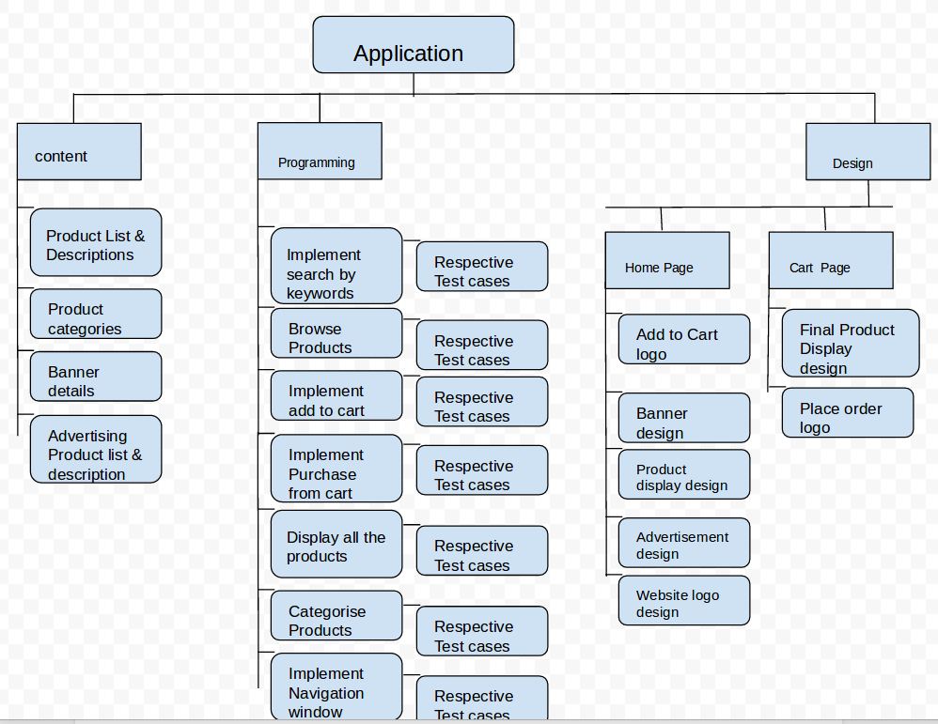

**Q3. All projects encounter some risk. New and unique projects have more unknowns and therefore more risks. A project manager needs to use an appropriate level of detail in risk planning enough to plan for all major and minor risks.**

**a) Assume yourself to be a project manager of a company involved in “new products development projects”, how are you going to do the risk planning to identify potential problems that could cause trouble for your project?**

**Ans.**

Definition: Risk mitigation planning is the process of developing options and actions to enhance opportunities and reduce threats to project objectives. Risk mitigation implementation is the process of executing risk mitigation actions. Risk mitigation progress monitoring includes tracking identified risks, identifying new risks, and evaluating risk process effectiveness throughout the project.

### Risk Identification: A more disciplined process involves using checklists of potential risks and evaluating the likelihood that those events might happen on the project. These checklists can be helpful to the project manager and project team in identifying both specific risks on the checklist and expanding the thinking of the team. The past experience of the project team, project experience within the company, and experts in the industry can be valuable resources for identifying potential risk on a project.

we can use the same framework as the work breakdown structure (WBS) for developing a risk

breakdown structure (RBS). A risk breakdown structure organizes the risks that have been

identified into categories using a table with increasing levels of detail to the right. The people

category can be subdivided into different types of risks associated with the people.

Risk Evaluation: After the potential risks have been identified, the project team then evaluates

each risk based on the probability that a risk event will occur and the potential loss associated

with it. Not all risks are equal. Some risk events are more likely to happen than others, and the

cost of a risk can vary greatly. Evaluating the risk for probability of occurrence and the severity

or the potential loss to the project is the next step in the risk management process.

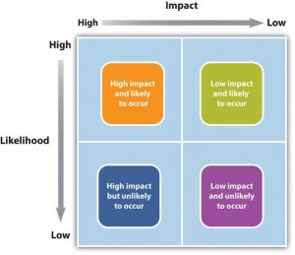

### 

### 

### 

### Risk Mitigation: After the risk has been identified and evaluated, the project team develops a risk mitigation plan, which is a plan to reduce the impact of an unexpected event. The project team mitigates risks in various ways:

* Risk avoidance
* Risk sharing
* Risk reduction
* Risk transfer

Each of these mitigation techniques can be an effective tool in reducing individual risks and the

risk profile of the project. The risk mitigation plan captures the risk mitigation approach for

each identified risk event and the actions the project management team will take to reduce or

eliminate the risk.

**b) What all methods will you use to assess the identified risks?**

**Ans.**

Reasons and methods of identified risk in a project are:

1. Changing circumstances, updates and new developments.
2. Detailed elaboration and further refinement of the overall project planning process.
3. Changes to the constraints (like scope, time and budget).
4. Changes to the initial project documentation (like Project Charter) resulted from further discussions and negotiations with the stakeholders.

Usually the reasons all together influence the project, so we need to consider every reason

carefully when creating a blueprint for a proactive approach to risk management. The process

of creating solutions and using specific methods for reducing occurrence of potential risk and

mitigating the negative impact of the risks is called project risk planning.

Project Risk Planning is a process for identifying how to carry out the activities of project risk

management. Its purpose is to determine actions to efficiently respond to the identified risks

that have a positive or/and negative effect on at least one project objective (such as cost, scope,

performance, time). The risk planning process should result in developing a feasible and

efficient plan for minimizing risk occurrence rate and exploiting available opportunities.

Risk planning is a necessary component within the overall project management process. It has

some benefits to a performing organization.

For example, if we practice effective risk planning procedures, we gain the following benefits:

* Saving both financial and non-financial resources.
* Increasing the efficiency and stability of activities and operations.
* Reducing legal liability.
* Protecting property and people involved in the project from harm and injury.
* Protecting and strengthening the reputation of your organization and employees.
* Increasing the likelihood of successful implementation.